AI Powered Hospital Information Management System

(Project Proposal)

Project Code
<Project code assigned by the Project Office>

Project Advisor
Mr. Aamir Zia

Project Manager
Dr. Muhammad Ilyas

Project Team
Ali Akbar BSCS51F22R036 (TL)
Muhammad Najee Ullah Noon BSCS51F22S043

Submission Date
<Provide the date when the proposal is submitted>

Table of Contents
1. Abstract 3
2. Background and Justification 3
3. Research Methodology 3
4. Project Scope 4
5. High level Project Plan 5
6. References 5

Abstract
Hospitals often face inefficiencies due to manual data handling and reliance on staff for recording patient information. This project proposes an AI-powered Hospital Information Management System (HIMS) that captures doctor-patient conversations, automatically extracts key medical details such as symptoms, diagnoses, and treatments, and securely stores them in a centralized database. By reducing administrative workload, improving accuracy in medical records, and enabling faster access to patient information, the system aims to enhance the overall quality of care while promoting the integration of AI technologies into healthcare workflows.

Background and Justification
“Modern healthcare institutions are increasingly facing challenges in managing patient records, ensuring accurate documentation, and reducing the administrative burden on medical staff [5].” Traditional systems often rely on manual data entry by assistants or doctors, which not only consumes valuable time but also increases the risk of errors and inconsistencies. “Providers have become frustrated and distracted with the documentation requirements which further hindered connectivity, and communication with the patient [1].”Additionally, patients frequently switch between hospitals, making it difficult to maintain unified medical histories that can support continuity of care.
To address these issues, the proposed AI-powered Hospital Information Management System (HIMS) introduces an intelligent platform with two main components:
- AI-Driven Medical Note Automation: Using speech-to-text and natural language processing, the system listens to conversations between doctors and patients, highlights medically relevant information, and presents it to the doctor for confirmation. Only after validation does the system store this structured data into the hospital’s database, ensuring accuracy and accountability.
- Integrated Management Dashboard: A comprehensive interface for hospital staff that allows them to manage patient records, confirm or edit AI-suggested notes, handle appointments, and securely share reports with patients.
“The core idea is to improve accuracy while keeping doctors in control, reduce time spent on repetitive documentation, and make healthcare records accessible and consistent across visits [2].” Built with advanced technologies such as Whisper AI for transcription, spacy/Med7 for medical entity recognition, React and Django for system development, and PostgreSQL for secure data storage, this solution is robust and adaptable to modern healthcare needs. “By reducing administrative workload and enhancing patient data management, the system ultimately supports improved efficiency and better patient care [3].”

Research Methodology
The research methodology for this project is structured into sequential steps to ensure systematic development and evaluation of the proposed hospital management system with AI-assisted note-taking. The first step involves requirement gathering and system design, where workflows of doctors, assistants, and patients will be studied to identify data flow, challenges in multilingual conversation, and necessary features. This phase will be followed by designing the system architecture, including the AI/NLP module, backend, frontend, and database schema.
The second step will focus on data preparation and model integration. “Speech-to-text tools such as Whisper AI will be trained or fine-tuned for multilingual transcription, while NLP pipelines will be built to extract relevant medical entities like symptoms, conditions, and prescribed tests [6].” In parallel, the backend and database will be developed using Django and PostgreSQL to store structured patient data securely.
The third step will involve frontend integration, where the React-based interface will allow doctors, assistants, and patients to interact with the system. Additional modules like automated note generation and secure access to reports will be implemented. Rigorous testing will be conducted at each stage to evaluate accuracy, usability, and error handling. Finally, the system will be validated in a simulated hospital environment, with feedback from stakeholders used to refine functionality before deployment.

Project Scope
The scope of the AI-powered Hospital Information Management System (HIMS) is defined by its focus on improving patient record management, reducing administrative workload, and supporting accurate medical documentation through AI assistance, while keeping doctors in control of validation. The project is specifically designed for healthcare institutions and has clear boundaries on what it will and will not cover.
Inclusions (What the System Will Do):
- AI-Assisted Medical Note Creation: “The system captures doctor-patient conversations, highlights relevant medical details (symptoms, diagnoses, tests), and presents them for doctor confirmation before saving to the database [4].”
- Centralized Patient Record Management: Hospitals can maintain structured medical histories, accessible to authorized staff across visits.
- Integrated Staff Dashboard: “Enables staff to verify or edit AI-suggested notes, manage patient data, and oversee hospital operations such as scheduling and reporting.
- Secure Patient Access: Patients can receive their reports digitally through their profile or via staff-provided printed documents [7].”
- Data Analytics for Hospitals: Aggregated data helps identify trends in patient issues, treatment effectiveness, and administrative workload.
Exclusions (What the System Will Not Do):
- Full Clinical Decision-Making: The system does not recommend treatments or prescribe medicines; it only records and structures doctor-validated information.
- Cross-Hospital Data Sharing: Patient data will not automatically transfer between hospitals unless formally integrated with external systems.
- Self-Registration by Patients: Initial patient accounts will be created by hospital staff; self-service registration will not be included in the current scope.
- Non-Medical Hospital Operations: The system will not handle unrelated tasks such as payroll, pharmacy stock management, or facility maintenance.

High level Project Plan

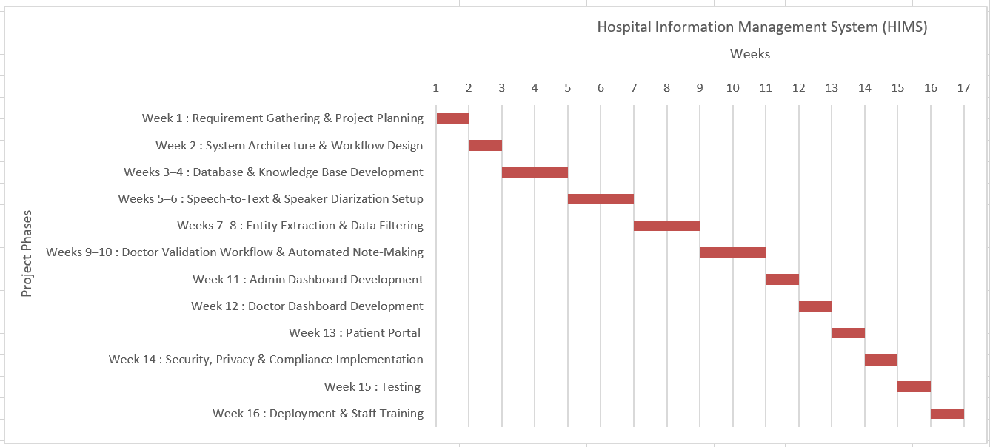

Figure 1 Gantt Chart

References

[1] Anastasia Pozdnyakova Piersa, Neda Laiteerapong, Sandra A. Ham, Felipe Fernandez del Castillo, Sachin Shah, Deborah L. Burnet & Wei Wei Lee. (2021, July 11). Impact of a medical scribe on clinical efficiency and quality in an academic general internal medicine practice. Retrieved from Springer Nature Link: https://link.springer.com/article/10.1186/s12913-021-06710-y

[2] Brian D Tran, Yunan Chen, Songzi Liu, Kai Zheng. (2020, May 1). How does medical scribes’ work inform development of speech-based clinical documentation technologies? A systematic review. Retrieved from JAMIA:
https://academic.oup.com/jamia/article-abstract/27/5/808/5809107

[3] Cameron G. Shultz and Heather L. Holmstrom. (2015, May 28). The Use of Medical Scribes in Health Care Settings: A Systematic Review and Future Directions. Retrieved from JABFM: https://www.jabfm.org/content/28/3/371.short

[4] Gregory Finley, Erik Edwards, Amanda Robinson, Michael Brenndoerfer, Najmeh Sadoughi, James Fone, Nico Axtmann, Mark Miller, David Suendermann-Oeft. (2018, June 1). An automated medical scribe for documenting clinical encounters. Retrieved from ACL Anthology: https://aclanthology.org/N18-5003/

[5] The digital scribe. (2018, October 16). Retrieved from npj digital medicine : https://www.nature.com/articles/s41746-018-0066-9

